Name: Sergio Gutierrez

bitbucket Repo: <https://bitbucket.org/SergioZGutierrez/homework/src/master/>

Exercise 4 (there’s two exercises/apps, within exercise 4):

These are the two folders containing my two apps:

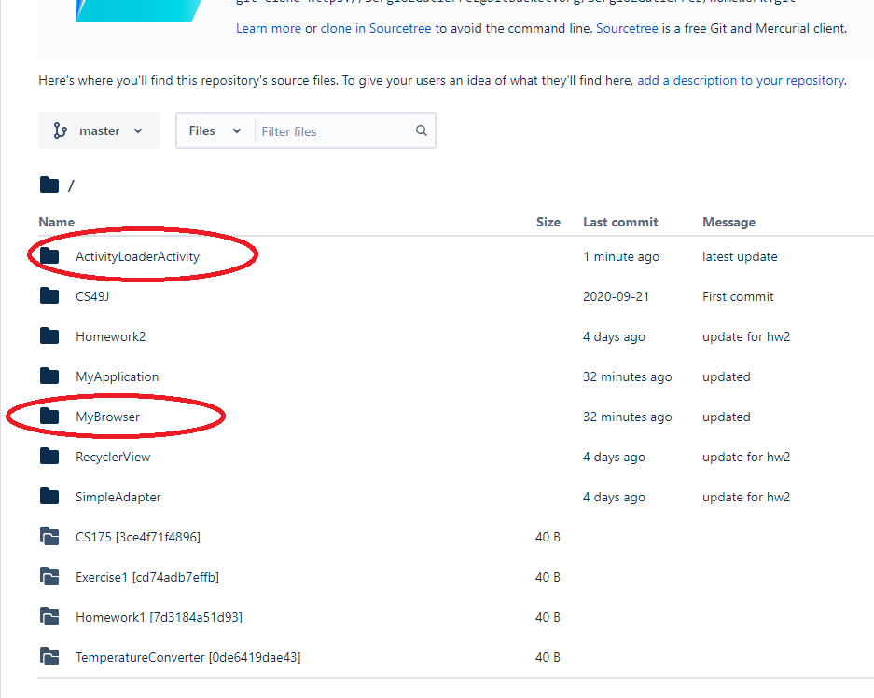

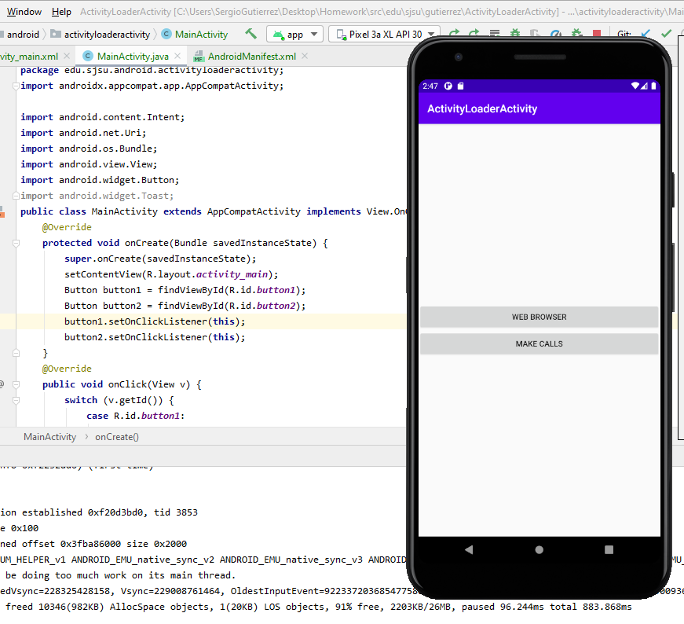

The exact pathways of where the .java files are located in my repository are:

<https://bitbucket.org/SergioZGutierrez/homework/src/master/ActivityLoaderActivity/app/src/main/java/edu/sjsu/android/activityloaderactivity/>

and:

<https://bitbucket.org/SergioZGutierrez/homework/src/master/MyBrowser/app/src/main/java/edu/sjsu/android/mybrowser/>